## Columbia University

**How to install Anaconda on Windows**

<https://www.anaconda.com/what-is-anaconda/>

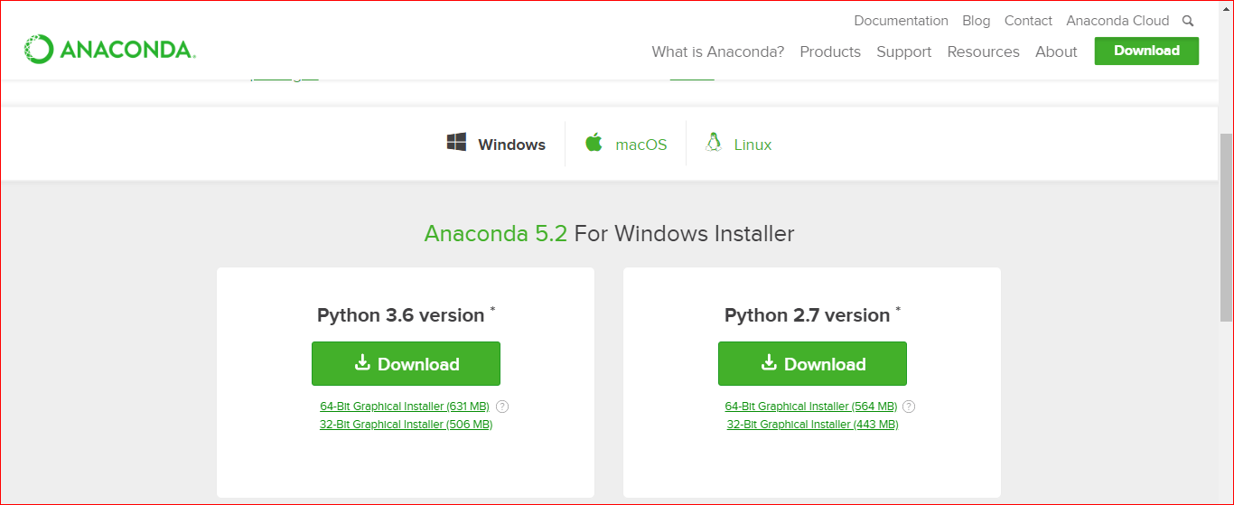

Durante el proceso de instalación, Habrá que seleccionar el PATH de la implementación de Python 3.5 en la carpeta del sistema.

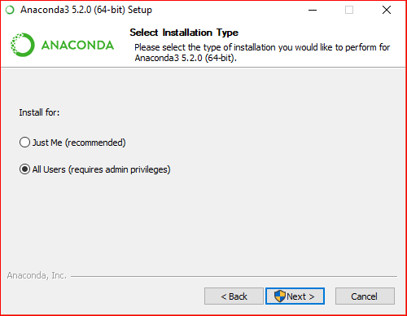 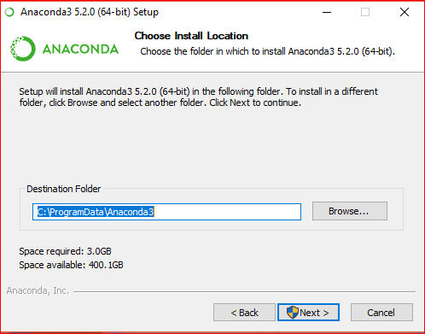

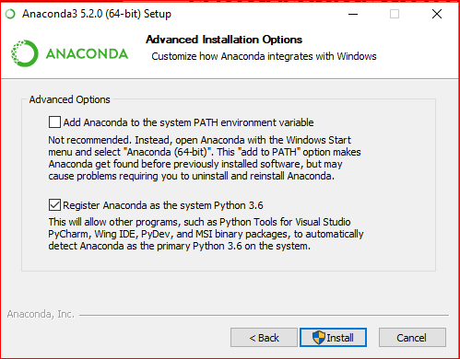 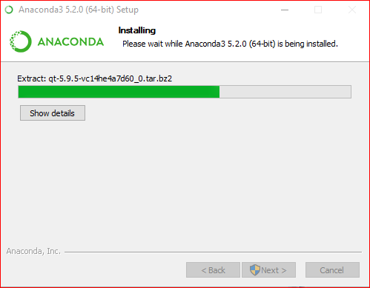

### Week1:

## 1.1 Python data types

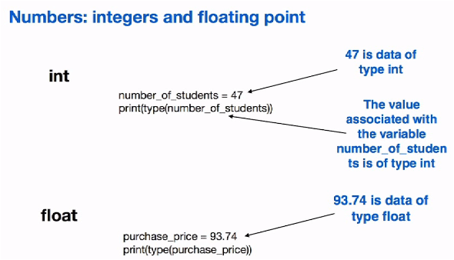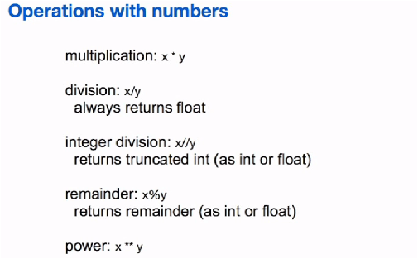

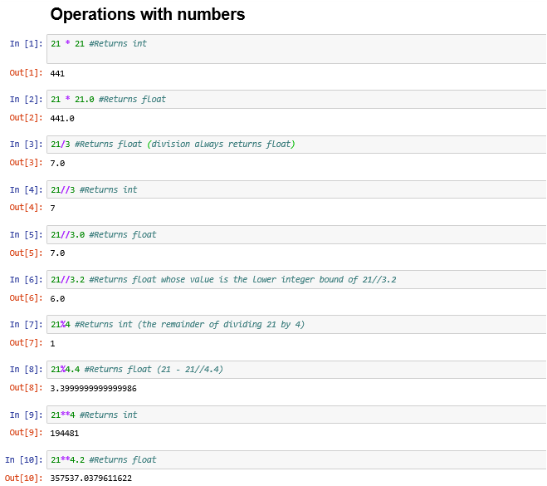

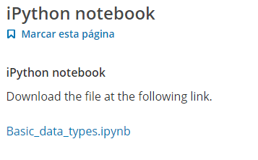

## 1.2 Strings in Python

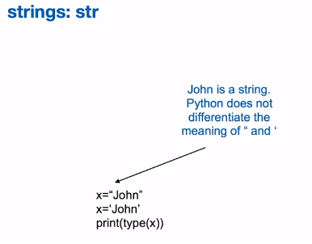 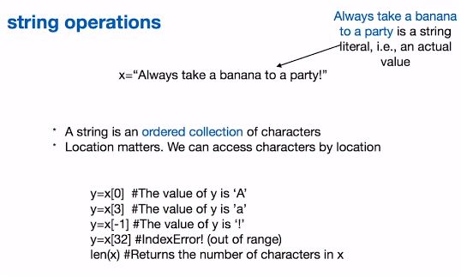

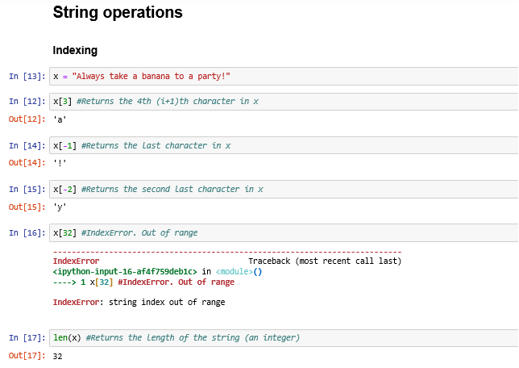

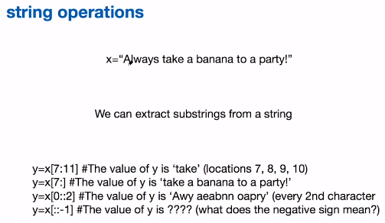

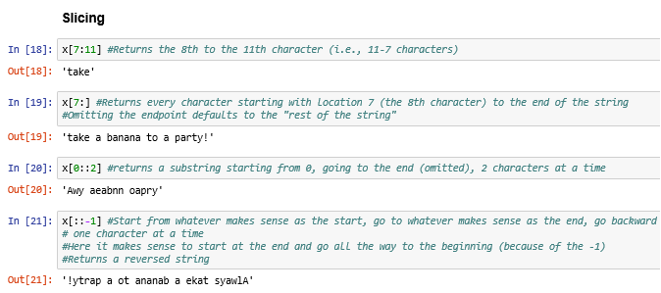

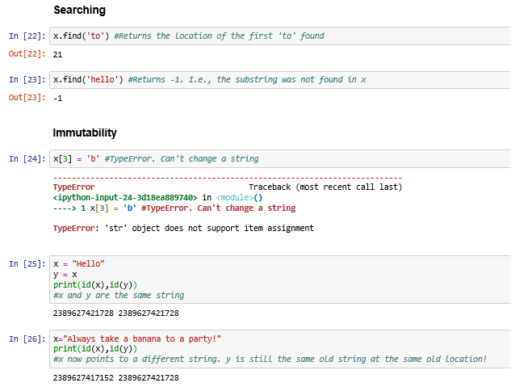

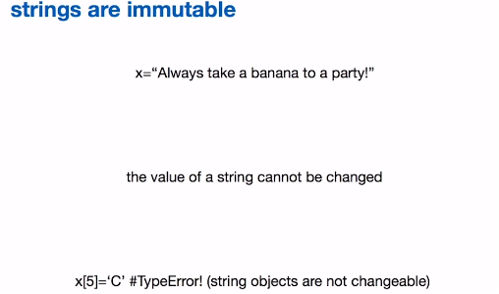



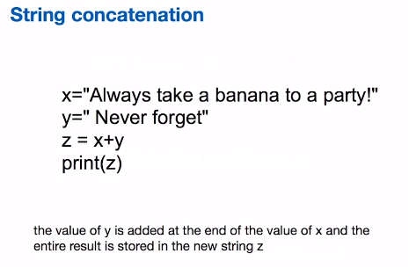

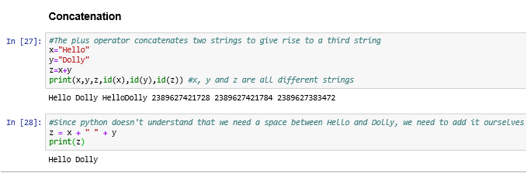

## 1.3 Variables and values

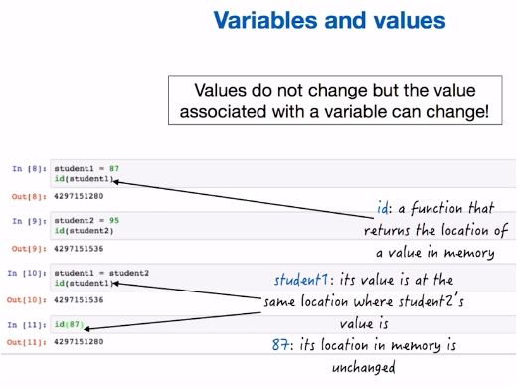

## 1.4 Boolean types in Python

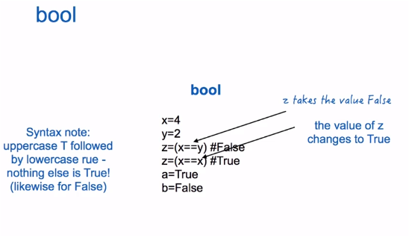

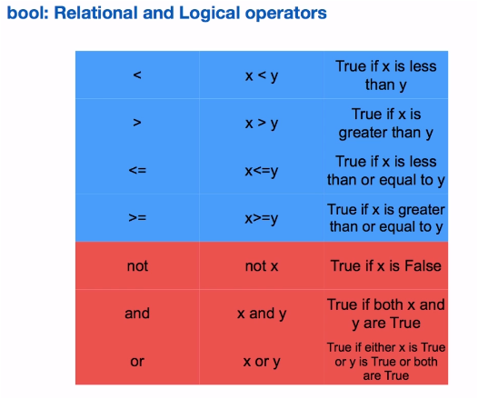

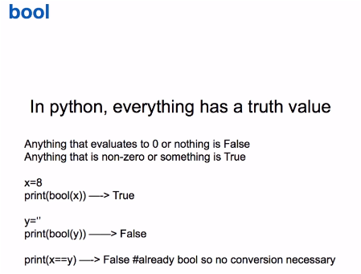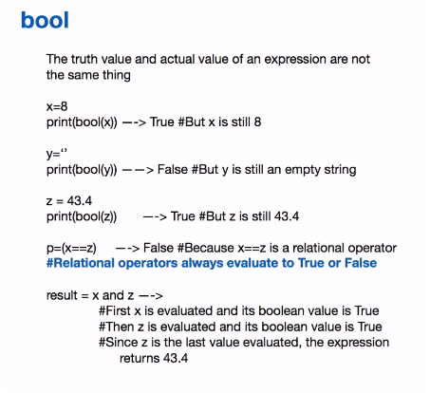

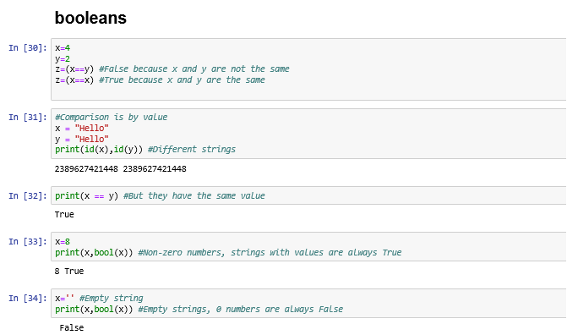

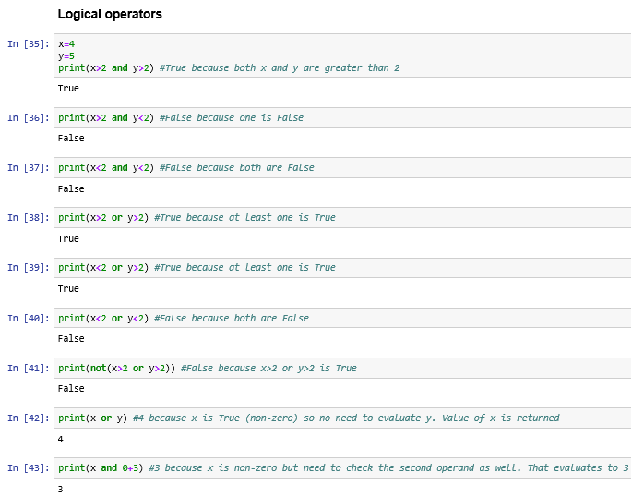

## 1.5 Assignment Operations

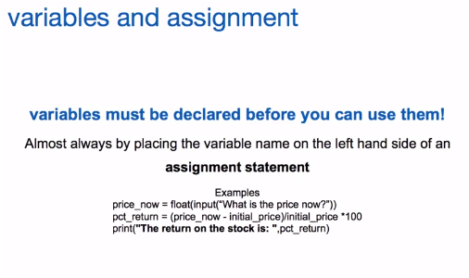

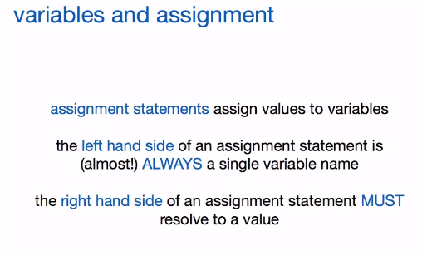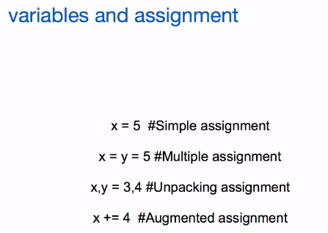

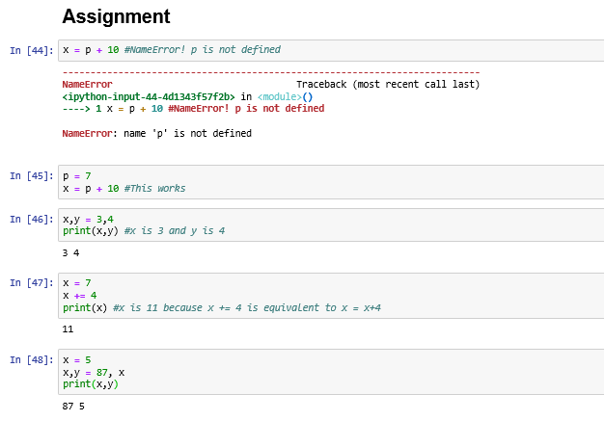

## 1.6 The if statement

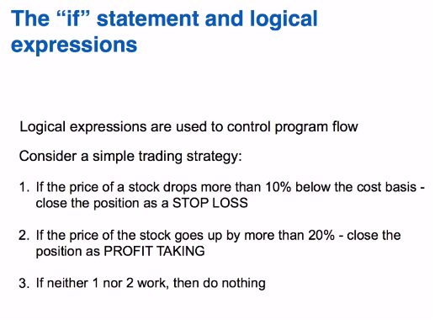

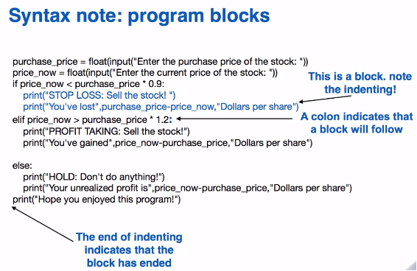

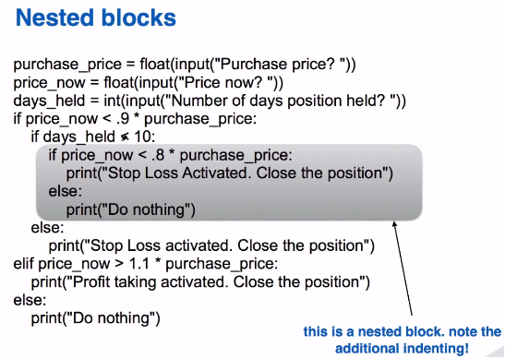

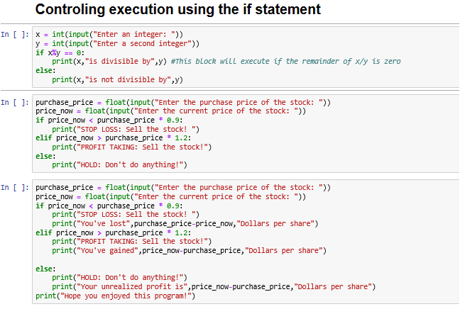

**Ejemplo:**

x = int(input("Enter an integer: "))

y = int(input("Enter a second integer"))

if x%y == 0:

print(x,"is divisible by",y) #This block will execute if the remainder of x/y is zero

else:

print(x,"is not divisible by",y)

**Ejemplo:**

purchase_price = float(input("Enter the purchase price of the stock: "))

price_now = float(input("Enter the current price of the stock: "))

if price_now < purchase_price * 0.9:

print("STOP LOSS: Sell the stock! ")

elif price_now > purchase_price * 1.2:

print("PROFIT TAKING: Sell the stock!")

else:

print("HOLD: Don't do anything!")

**Ejemplo:**

purchase_price = float(input("Enter the purchase price of the stock: "))

price_now = float(input("Enter the current price of the stock: "))

if price_now < purchase_price * 0.9:

print("STOP LOSS: Sell the stock! ")

print("You've lost",purchase_price-price_now,"Dollars per share")

elif price_now > purchase_price * 1.2:

print("PROFIT TAKING: Sell the stock!")

print("You've gained",price_now-purchase_price,"Dollars per share")

else:

print("HOLD: Don't do anything!")

print("Your unrealized profit is",price_now-purchase_price,"Dollars per share")

print("Hope you enjoyed this program!")

## 1.7 Functions (Part 1)

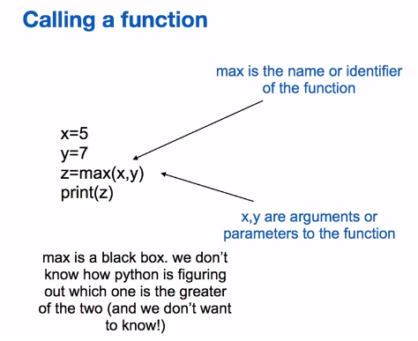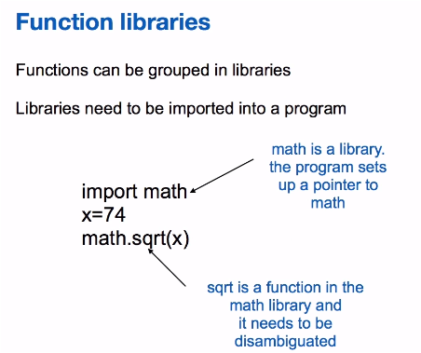

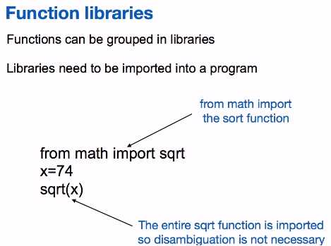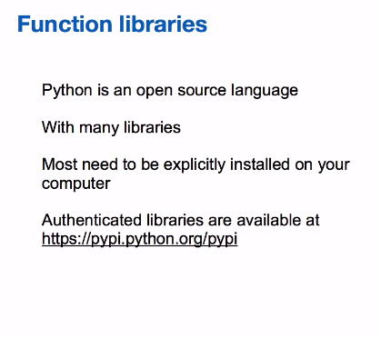

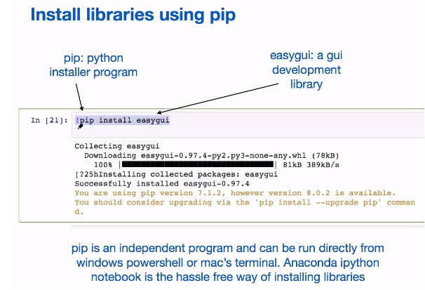

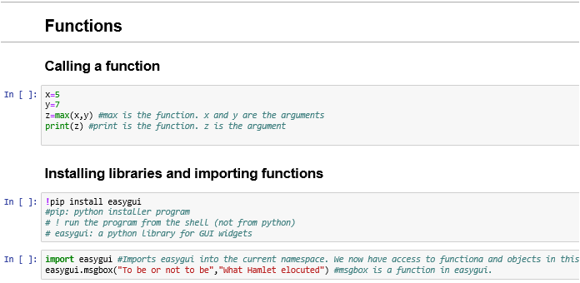

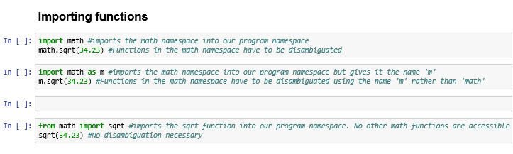

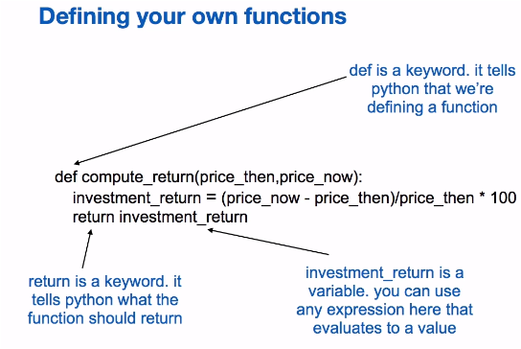

## 1.8 Functions (Part 2)

## 

## 

## 

## 

## 

## 

## 

### Week2:

## 2.1 Lists

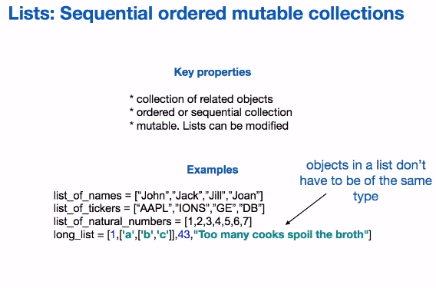

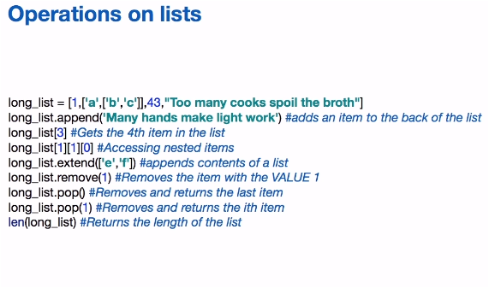

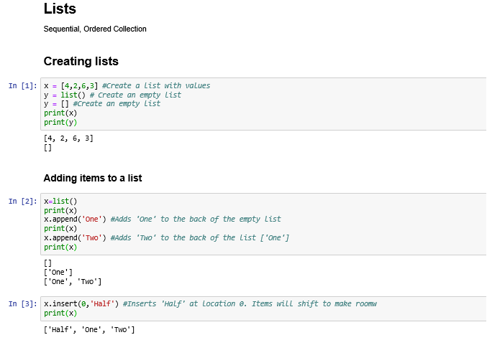

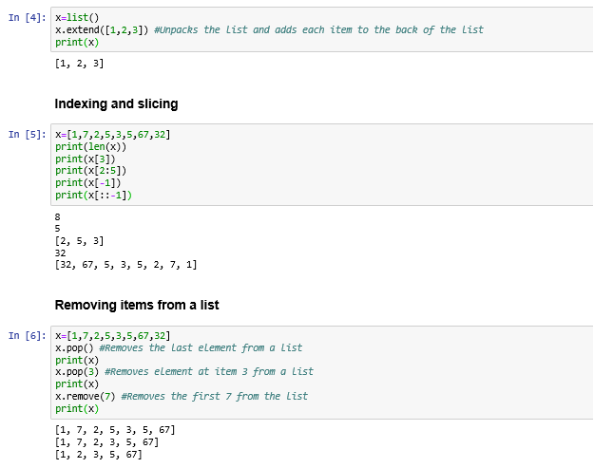

## 2.2 Mutability

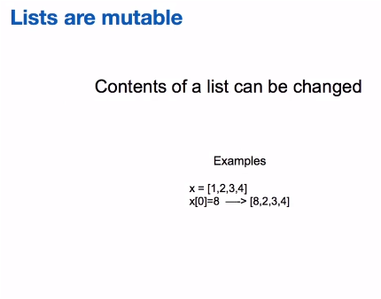 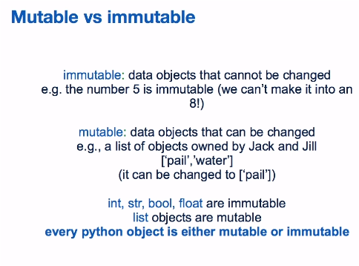

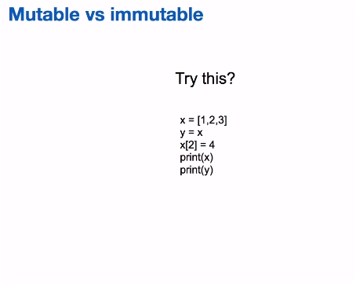 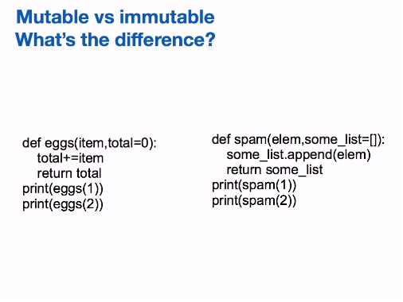

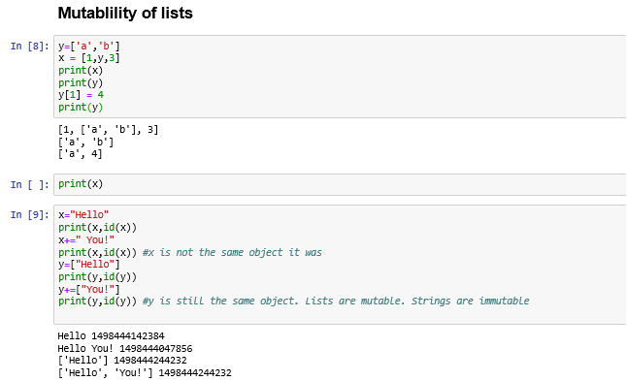

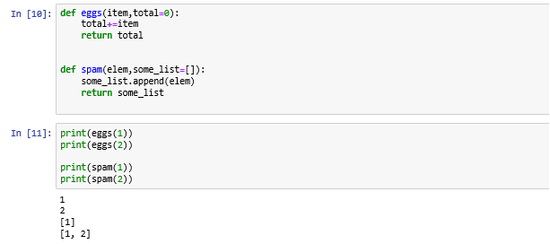

## 2.3 Iteration

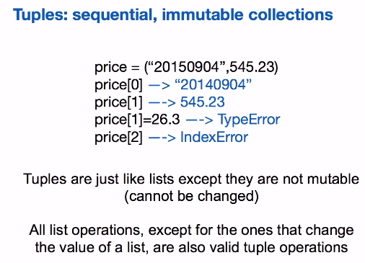

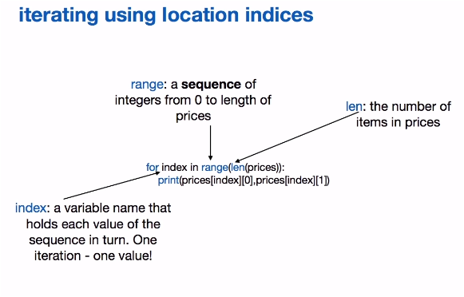 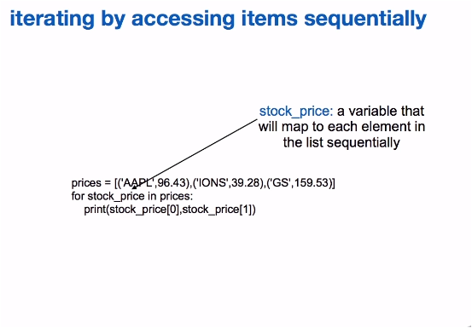

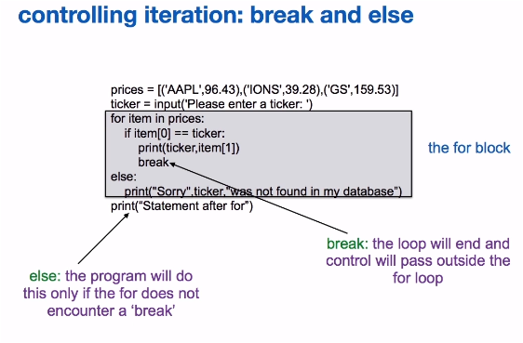

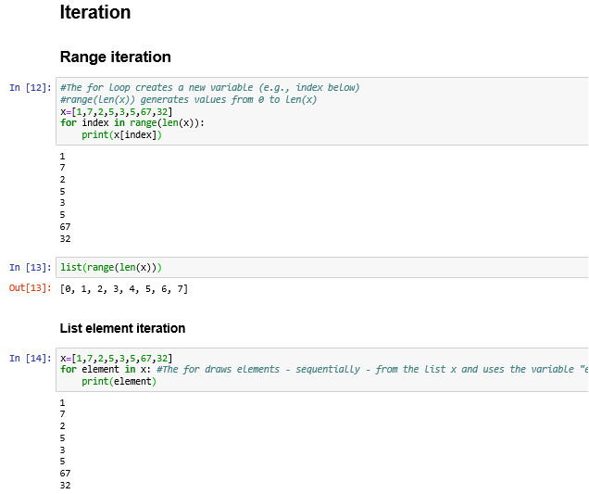

## 2.4 Example

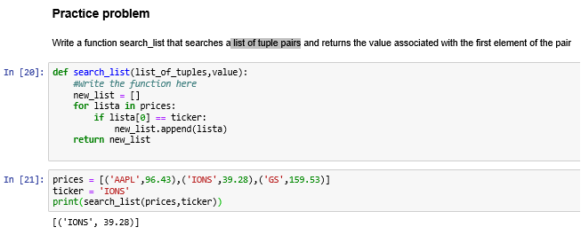

## 2.5 Dictionaries and sets

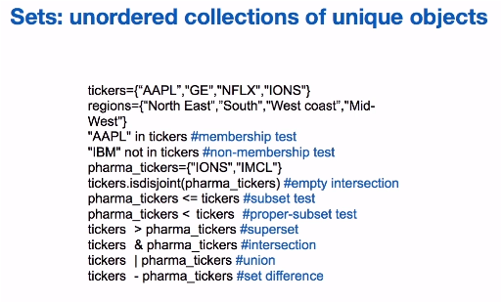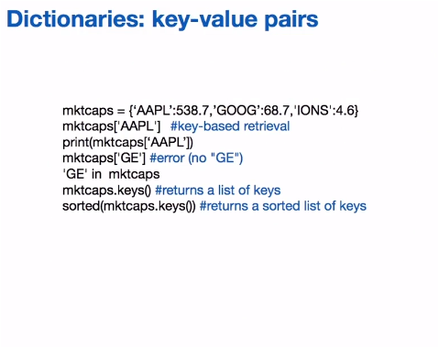

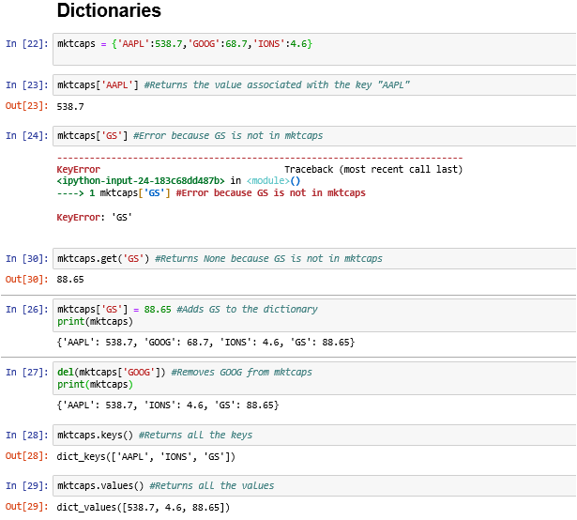

## 2.6 datetime library I

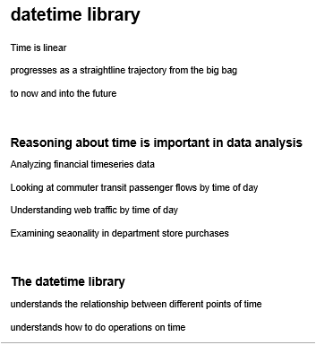

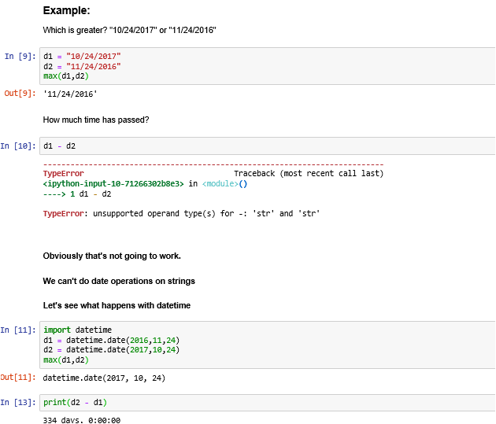

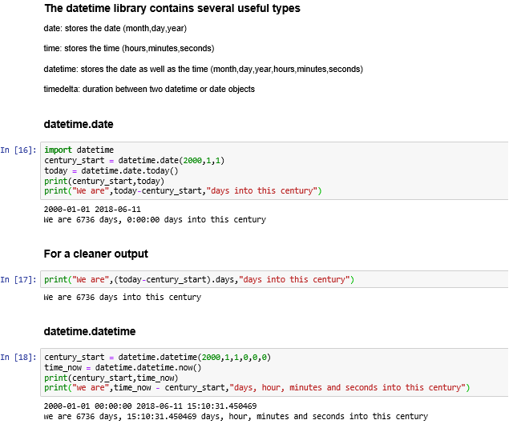

## 2.7 datetime library II

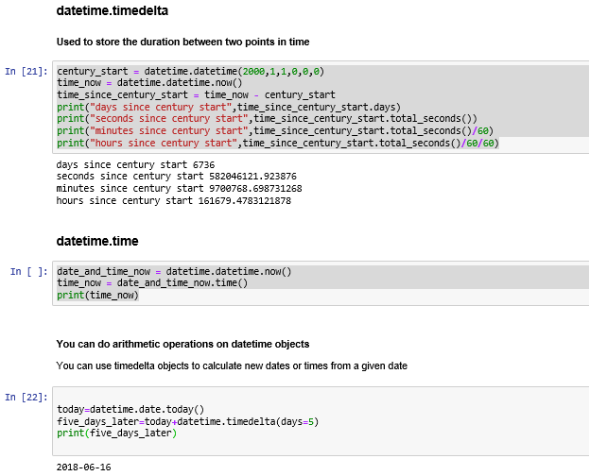

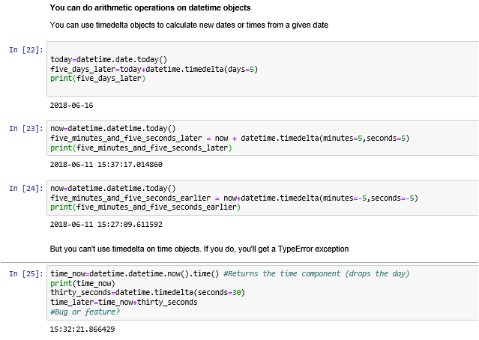

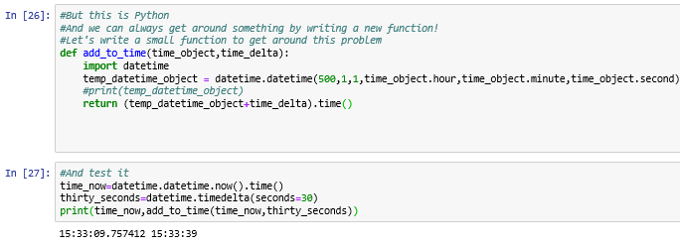

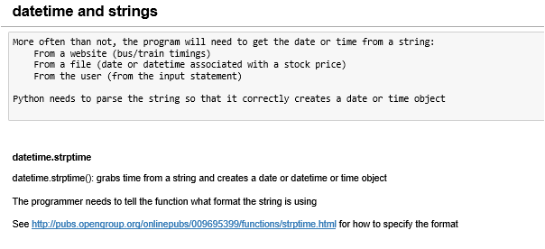

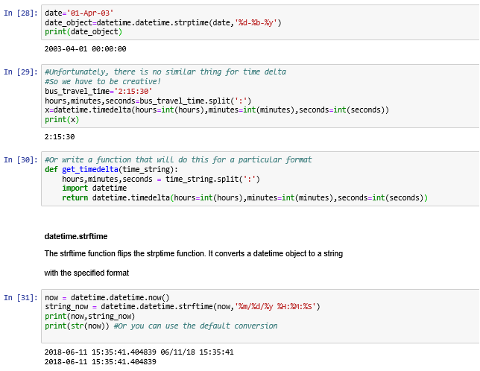

## 2.8 Bucketing time Part I

## 

## 

## 

## 

## 

### Week3:

## 3.1 Getting data (Part 1)

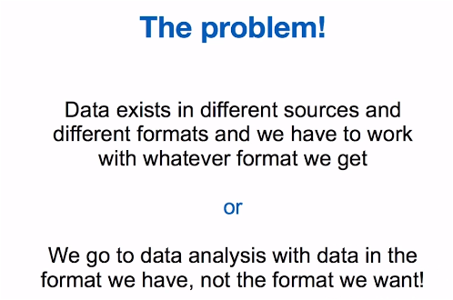 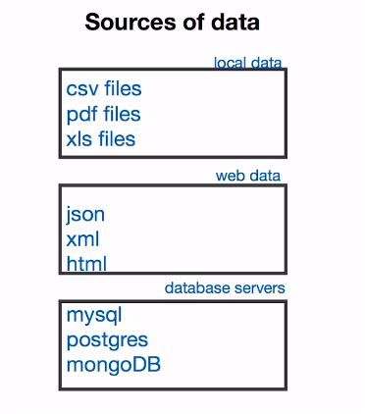

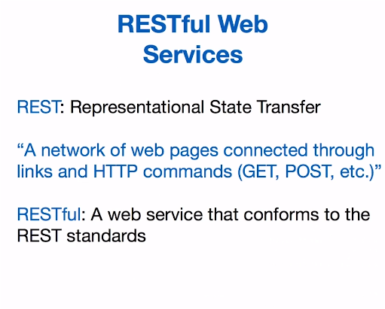 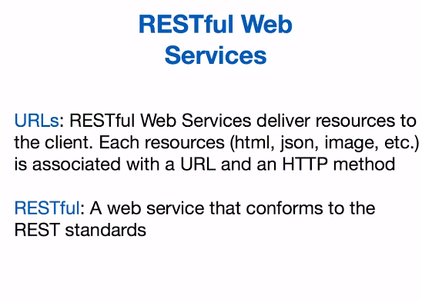



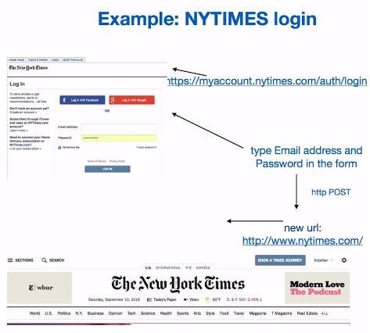

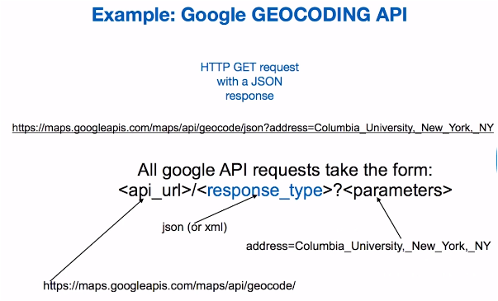

## 3.2 Getting data (Part 2)

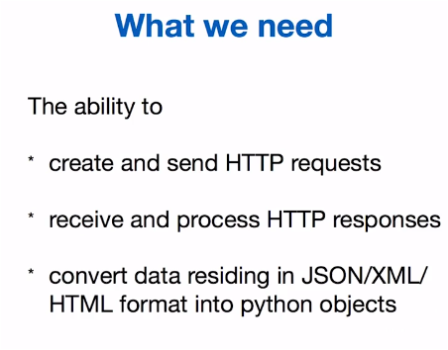 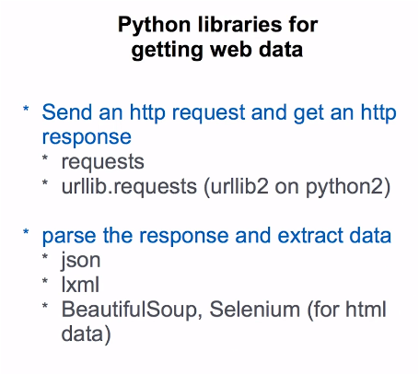

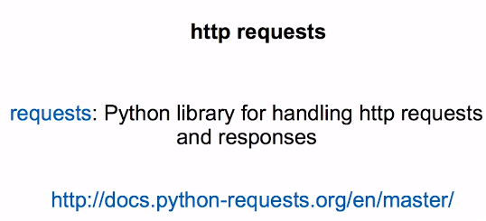

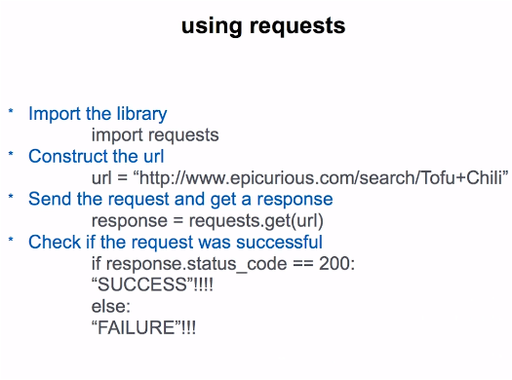 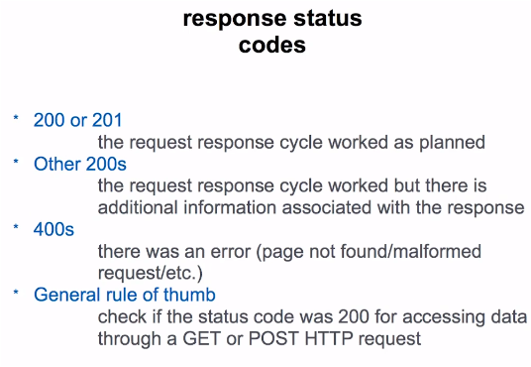

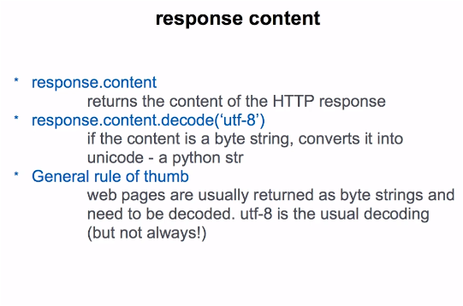

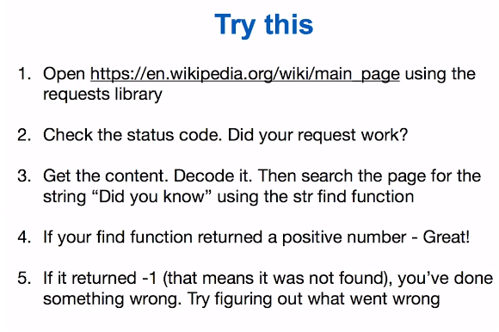

**IMPORTANTE: se debe instalar**

**C:\>pip install requests**

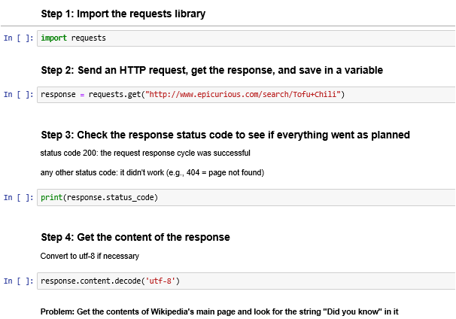

url = "https://en.wikipedia.org/wiki/main_page"

#The rest of your code should go below this line

wiki_page_response = requests.get(url)

wiki_text = wiki_page_response.content.decode('utf-8')

wiki_text.find('Did you know')

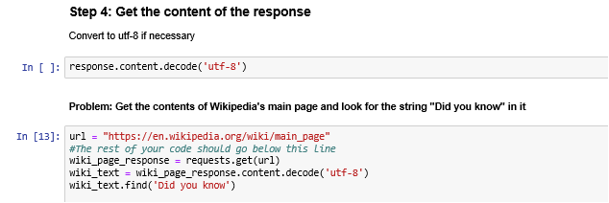

## 3.3 Web Data Formats

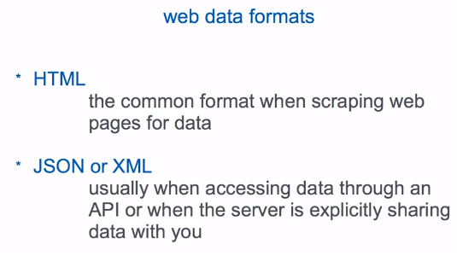 

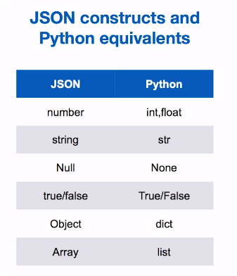 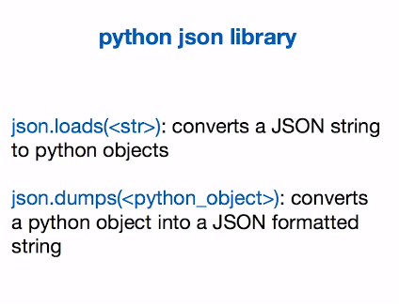

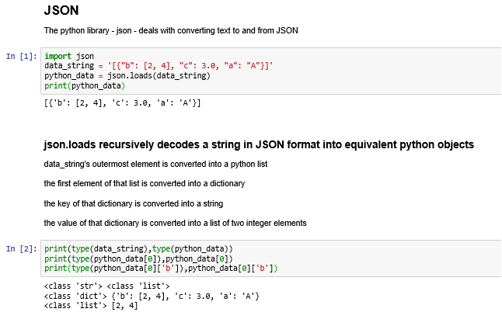

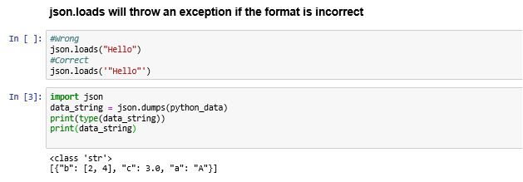

## 3.4 JSON, Google API (Part 1)

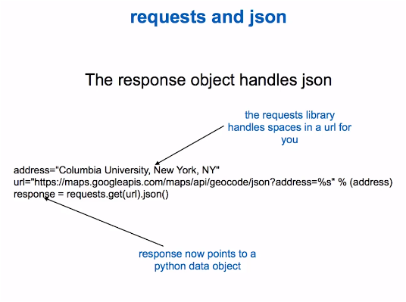

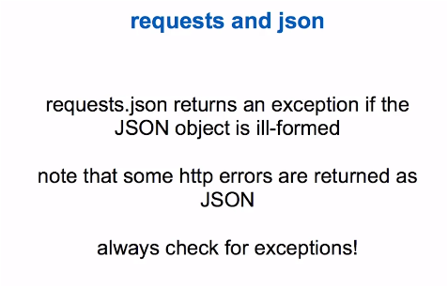

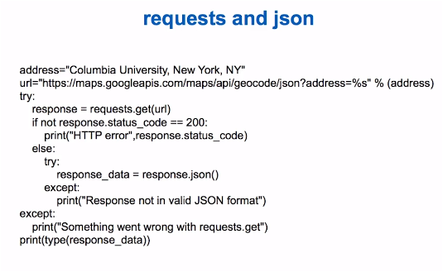

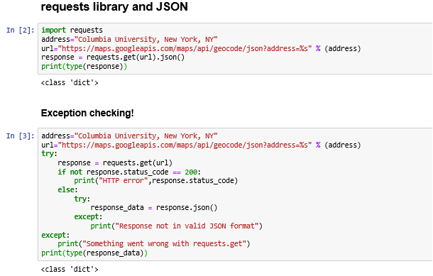

import requests

address="Columbia University, New York, NY"

url="https://maps.googleapis.com/maps/api/geocode/json?address=%s" % (address)

try:

response = requests.get(url)

if not response.status_code == 200:

print("HTTP error",response.status_code)

else:

try:

response_data = response.json()

except:

print("Response not in valid JSON format")

except:

print("Something went wrong with requests.get")

print(type(response_data))

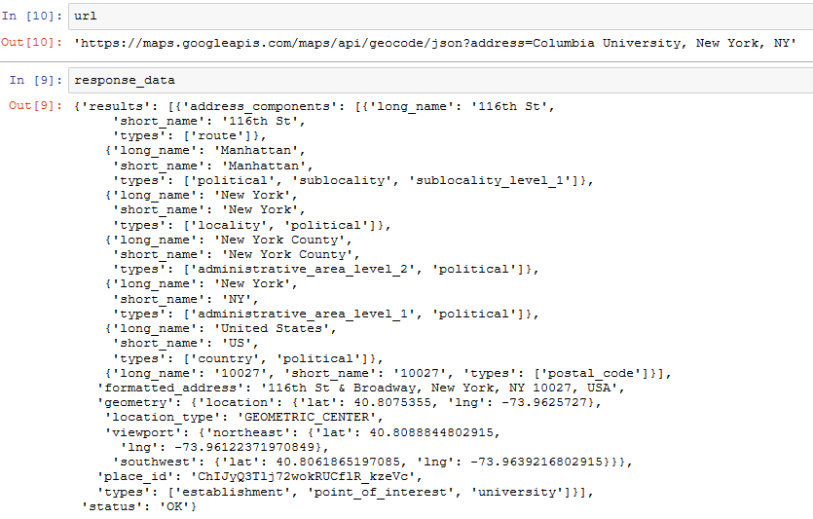

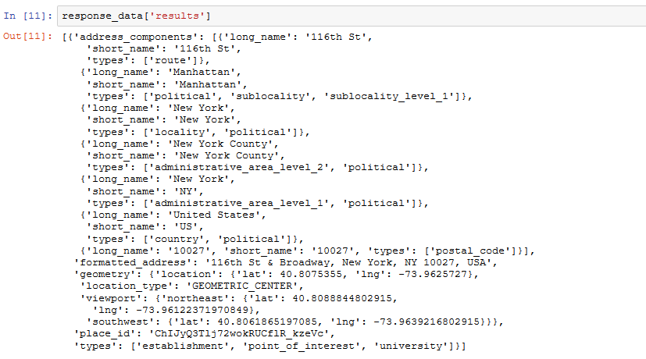

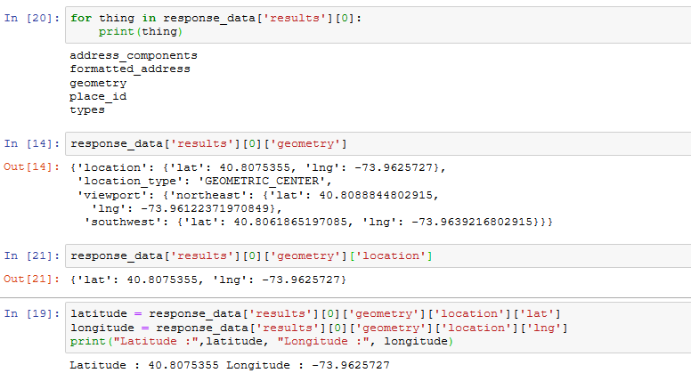

## 3.5 JSON, Google API (Part 2)

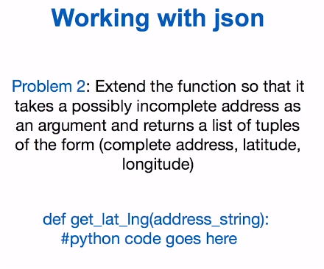

Resuelto:

**W3_Practice_1_return_latitude_longitude_tuple**

def get_lat_lng(address_string):

#python code goes here

import json

import requests

url="https://maps.googleapis.com/maps/api/geocode/json?address=%s" % (address_string)

try:

response = requests.get(url)

if not response.status_code == 200:

print("HTTP error",response.status_code)

else:

try:

response_data = response.json()

except:

print("Response not in valid JSON format")

except:

print("Something went wrong with requests.get")

latitude = response_data['results'][0]['geometry']['location']['lat']

longitude = response_data['results'][0]['geometry']['location']['lng']

return latitude, longitude

**W3_Practice_2_return_complete_address_latitude_longitude_tuple**

def get_lat_lng(address_string):

#python code goes here

import json

import requests

url="https://maps.googleapis.com/maps/api/geocode/json?address=%s" % (address_string)

try:

response = requests.get(url)

if not response.status_code == 200:

print("HTTP error",response.status_code)

else:

try:

response_data = response.json()

except:

print("Response not in valid JSON format")

except:

print("Something went wrong with requests.get")

latitude = response_data['results'][0]['geometry']['location']['lat']

longitude = response_data['results'][0]['geometry']['location']['lng']

address = response_data['results'][0]['formatted_address']

#print("Latitude :", latitude, "Longitude :",longitude)

#print("Address :", address)

return address, latitude, longitude

## 3.6 XML (Part 1)

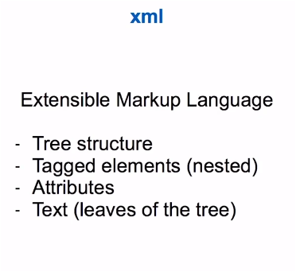

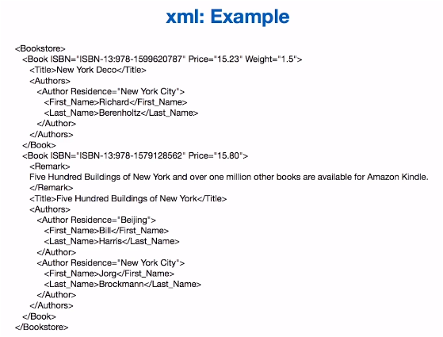

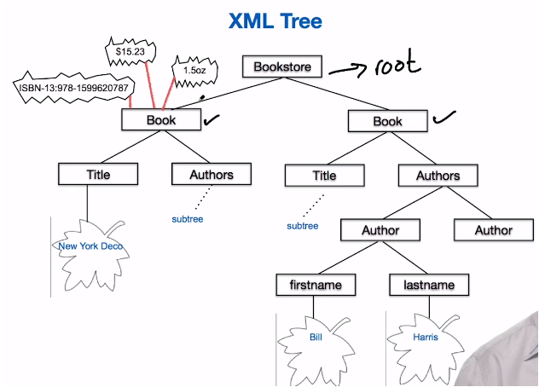

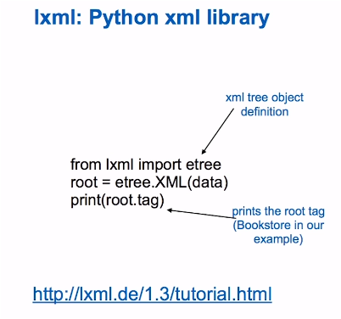 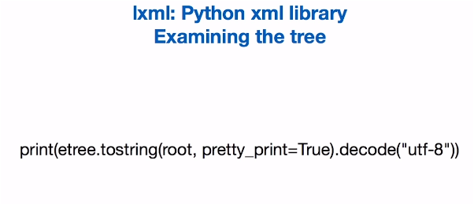

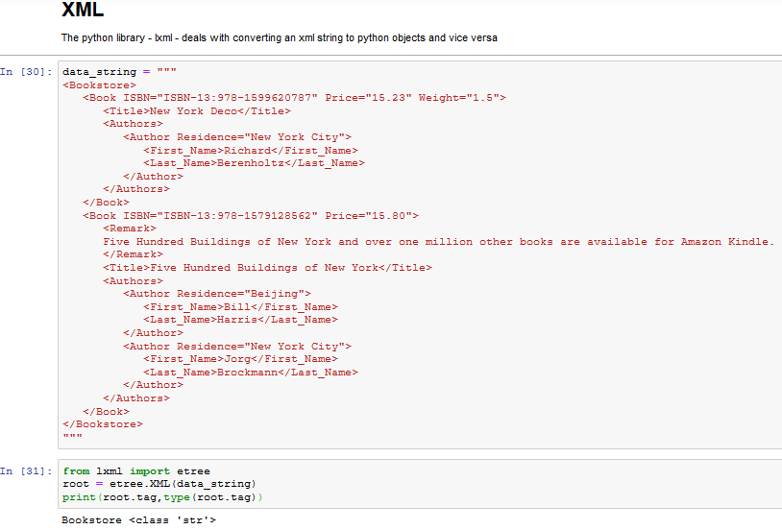

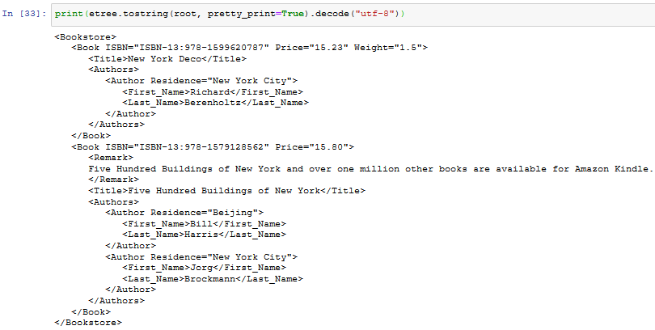

## 3.7 XML (Part 2)

